Frigate signalled 'Now some two thousand miles
10 NAVY NEWS September, 1959

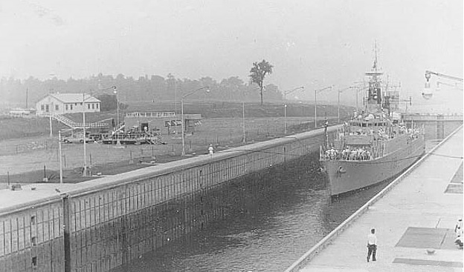
from the open sea'
H.M.S. Ulster entering the Eisenhower Lock

overhead, and ships in the harbour hooted their sirens in a raucous welcome. Rockets exploded in the air releasing the flags of the U.S.A, Canada and Great Britain, and as they fluttered slowly down, the Royal barge carrying the distinguished visitors sped swiftly ashore.
The streets of Chicago were crowded with cheering people, and many curious glances were cast that day at the men in white naval uniform who, until then, had only been seen on the cinema screen or in illustrated books. This memorable day came to an end with a spectacular firework display centred over the Royal Yacht.
The ships formed up and left Chicago at midnight and there followed a quiet period on the journey back up Lake Michigan. Saying farewell to the American escorts, the Yacht and her close escort proceeded through the locks at Saulte St. Marie and entered the last of the five Great Lakes, Superior.
Mist and rain became the pattern of the weather as the ships steamed steadily on to the furthermost point, Lakehead, and the twin towns of Port Arthur and Fort William. This was the farthest point of the cruise, and it was from here that the Captain signalled Admiralty, "H.M.S. Ulster arrived Fort William: Ulster is now some 2,000 miles from the open sea and 602 feet above sea level." This must surely be a unique.
This must surely be a unique position in which to find a British warship.
H.M. the Queen and Prince Philip left Britannia at Port Arthur and commenced their journey overland to the east coast of Canada.
Locks and further progress was inadvisable. The ship anchored for the night, and next morning, after several attempts—each thwarted as the fog settled again — the ship finally got under way again, and entered the Snell and Eisenhower Locks during the afternoon.
THOUSAND ISLANDS
These two locks raised the ship 89 feet on to the new man-made Lake St. Lawrence. This 28-miles-Jong lake serves a dual purpose, providing the motive force for the huge Moses Saunders hydro-electric power station, and, at the same time, covering beneath its placid surface the treacherous rapids of the Long Saulte. Passing through the last of the seven locks—the Iroquois—the ships proceeded further upriver, and anchored off Brockville for the night:
Sunday morning was bright and sunny as Britannia and the close escort steamed on up towards Lake Ontario. The St. Lawrence around this region is dotted with hundreds of tiny picturesque islands, most of which are inhabited by well-to-do Americans, and the area is appropriately named "Thousand Islands."
NIAGARA FALLS
The ships were here surrounded.by hundreds of small craft all flying gaily coloured flags and carrying waving cheering people. These trim-looking boats bobbed and bounced along flinging up clouds of spray as they raced to keep up. Then as mile succeeded mile, they dropped back steadily and with a final wave turned and headed back.
The next stop was a brief one at Kingston, then on across Lake Ontario to Toronto. there a
H.M.S. ULSTER ESCORTS ROYAL YACHT THROUGHOUT SEAWAY
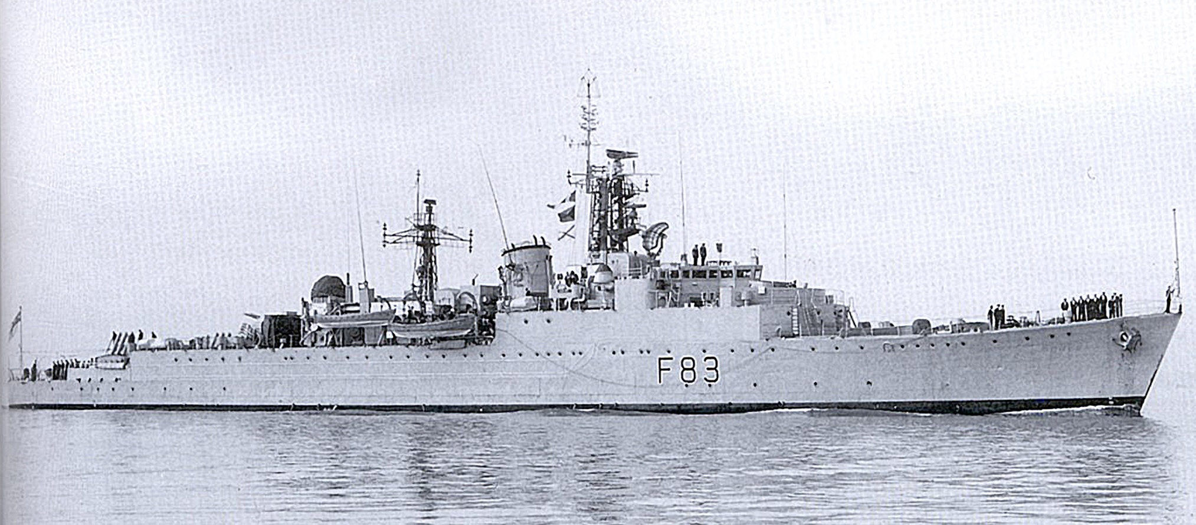
On the arrival of the Royal Party, s Britannia and the escort left for Gaspe where the Queen was to review units of the Canadian Navy. A blanket of fog enveloped the ships that evening, and was still hanging around at 8 a.m. the next day. By 9 a.m., however, it had rolled away revealing blue skies, and the sun was shining as the Royal Yacht and the escort steamed slowly down the line.
Some 14 ships, including the two British submarines Ambush and Alderney (on loan to the Canadian Navy. were lying at anchor in review
ships weighed anchor and, taking stations on Britannia, headed for the Saguenay River.
SIXTEENTH BIRTHDAY
Britannia and the close escort proceeded up the Saguenay the next morning, the remainder of the Canadian ships anchoring at the entrance of the river. The trip up the river was a memorable one, and even the overcast skies did not hide the splendid scenery. Unnoticed by the ship's company, Ulster this day celebrated her sixteenth birthday, with a
The next call was at Quebec, and this was, for most, the first run ashore in Canada. Our Canadian partners in the close escort left us here, and were relieved by H.M.C.S. Gatineau and H.M.C.S Kootenav. Ulster was berthed alongside beneath the Heights of Abraham, and many took the opportunity of scaling the historic cliffs (via the steps!) and looking around the city.
From Quebec to Three Rivers for a brief stay, and then on to Montreal where the ships — Canadian, British and American—were assembling for the official opening ceremony of the Seaway. The ships were open to visitors and received a great welcome.
At noon on Friday, June 26, Britannia, carrying H.M. the Queen
On June 15 Ulster left Ireland Island in Bermuda and sailed for Seven Islands in the estuary of the St. Lawrence River. At Seven Islands the ship joined up With the Canadian Frigates Restigouche and St. Croix to act as close escort, and together with H.M. Yacht Britannia, awaited the arrival of H.M. The Queen and Prince Philip from Newfoundland
H.M.S. Ulster celebrated her 16th birthday during her passage of the St Lawrence Seaway
_{H}MS Ulster is a Type 15 Frigate under the command of Cdr. Cameron Rusby, R.N., and for the past few weeks has been detached from her normal duties on the West Indies Station to act as escort to hm. the Queen on the occasion of the Royal Tour of Canada. It is not proposed here to relate in detail the events of the Royal Tour, which have been well covered in the National Press
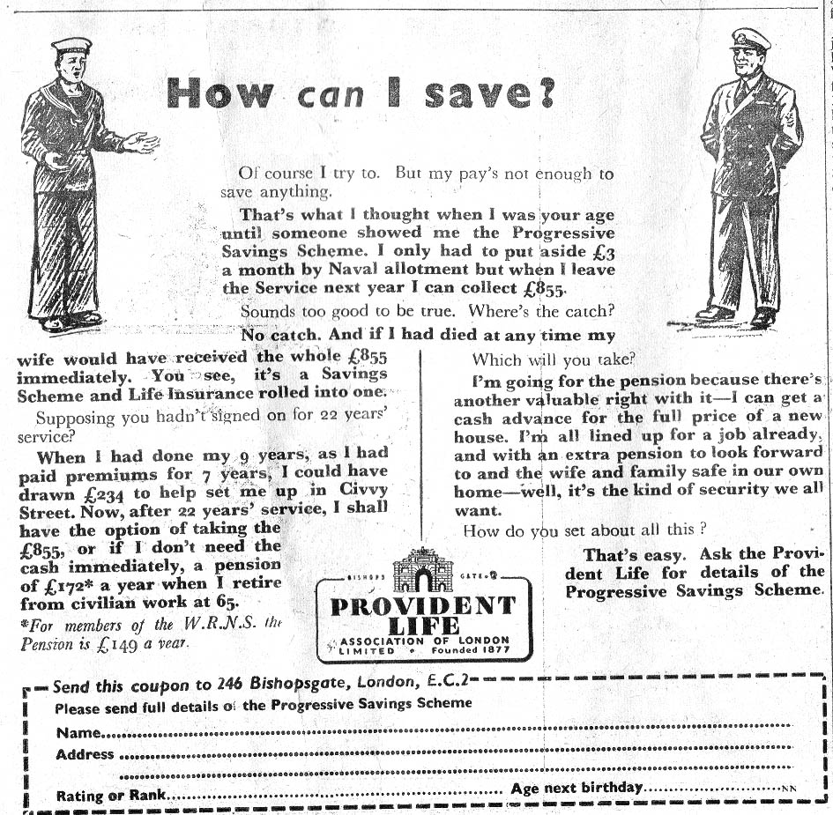
FORT WILLIAM'S WARM WELCOME
The people of Fort William made the ship's company really welcome, and on the occasions when the ship was open to visitors, even torrential rain could not dampen their enthusiasm and the upper deck was crowded with people. Dances and social evenings were organised ashore by various Legions, and were enjoyed by many. The men of the Naval Reserve at H.M.C.S. Griffon extended a warm welcome to the ships, and the various messes were open to the ships' companies during the whole of the stay.
Ulster's .next port of call was Alpena, where the people were waiting to give the ship a most enthusiastic welcome. A barbecue and a sight-seeing tour were organised, and many ratings were entertained privately. In short, everyone succeeded in packing a really good time into two hectic days.
From Alpena to Sarnia for fuel, and thence to Detroit where the ship shared a most hearty welcome with units of the U.S. Navy. Ulster saluted the port on' arrival with 21 guns, the honours being returned from the Coast Guard base at Belle Isle. Thus were the first shots exchanged between the U.S. and the British in that area since the war of 1812.
Techniques of a different nature were exhibited by the Detroit City Police in a pistol shooting match against the ship's team. Leading a first-class team of Detroit "Bobbies" was Inspector Reeves (Olympic and International Champion), who gave a superb display of marksmanship. The teams and spectators later enjoyed a barbecue, and returned to the ship in the evening after an enjoyable and most interesting time.
NIGHT RETURN
Leaving Detroit, the journey back through the Welland Locks was made during the night and without incident. The past few weeks have been outstanding in a commission which is now drawing to an end, and will long be remembered by the ship's company as a most interesting and eventful one.

Sightseers made good use of the two-day stay touring the rapidly expanding city, and a hundred or so ratings visited the famous Niagara Falls.
From Toronto, the next stage of the journey was across the Niagara Peninsula through the 27½ -mile-long Welland Canal to Lake Erie. The difference in level of the two lakes is 326½ feet and Ulster climbed this height in eight huge "steps" through the Welland Locks system. This system has been in use since 1931, and the canal was dredged as part of the Seaway scheme to take vessels of deeper draft.
Here the ships' companies were very well received and entertained by the ship's company of H.M.C.S. Hunter in the modern building which is the headquarters of the Naval Reserve. The city was "wide open"; barricades had been erected across the roads, and dancing took place in the streets, novelty enjoyed by everyone.
After a brief but happy stay in Windsor, the ships left for Sarnia to fuel and, although the stay was only .for a matter of six hours, quite, number of the ship's company went ashore to have a look around this small town. H.M. the Queen and Prince Philip arrived in Britannia about 9 p.m. and were accorded a terrific welcome when they came ashore. In fact ratings had difficulty in getting back to the ship through the crowded streets where people had been waiting patiently three and four hours for a glimpse of the Royal couple.
From Sarnia across Lake Huron to a tiny place with a long name...Penetanguishene, and after a brief stay there with no leave, the Yacht and the close escort sailed for Lake Michigan. The escort was joined en route by-units of the U.S. Navy, and the ships made an impressive picture as they steamed beneath the new Mackinac suspension bridge and across Lake Michigan heading for Chicago.
CHICAGO'S WELCOME
Chicago had gone to great lengths to make this visit of H.M. the Queen I an outstanding one. Fire-fighting tugs sent up geysers of water high into the air; formations of aircraft roared by

co-ordinated gun salute, and the hearty cheers of the assembled ships' companies broke the stillness of the morning. Church bells could be heard faintly in the distance, and it was, in all, an impressive start to the Tour.
The Queen and Prince Philip spent a few hours ashore in Gaspe, and then, in the afternoon, all the assembled
total of 234,674 miles steamed since the day she first commissioned.
At the head of the Saguenay River lies Port Alfred, and the Queen and Prince Philip made a brief visit there, after which the four ships weighed and proceeded back down river again
and President Eisenhower, steamed through the ceremonial "gateway"
Into the St. Lamberts lock and the new Seaway was declared open. Following Britannia through the gateway, Ulster became the first British warship to use this wonderful "hydraulic staircase" to the Great Lakes.
A heavy mist settled when the ship had passed through the Beauharnois

